**PRACTICAL No.2**

**AIM: Write a Program to read two integer numbers and print the values of the entered numbers.**

**STEPS:**

#Write a Program to read two integer numbers and print the values of the entered numbers.

num1=input("Enter first number: ")

num2=input("Enter second number: ")

print("Entered numbers: " + num1, num2)

_______________________________________________________________________________________________________________________________________________________________________________________________________________________________________________________________________________________________________________________________________________________________________________________________________________________________________________________________________________________________________________________________________________________________________________________________________________________________________________________________________________________________________________________________________________________________________________________________________________________________________________________________________________________________________________________________________________________________________________________________

**SCREENSHOT:**

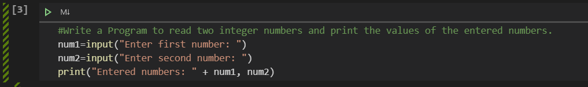

**Date:**